**WT Assignment 2**

**Neeti Kurulkar**

**Restaurant Website**

**Website:**

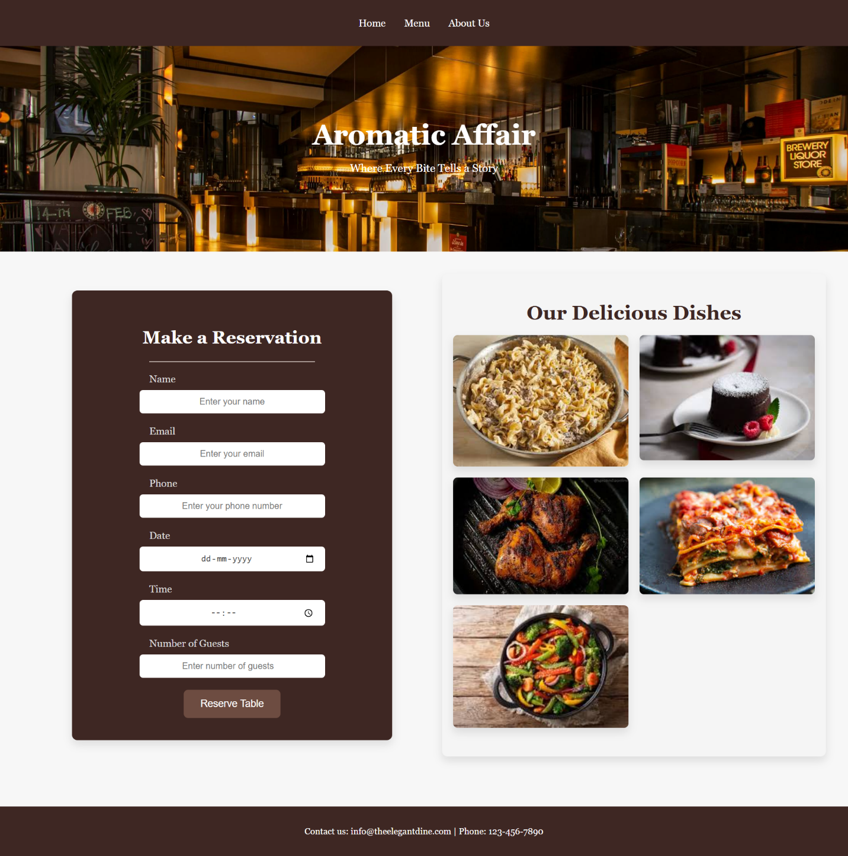

**Code:**

1. **index.html**

<!DOCTYPE html>

<html lang=**"en"**>

<head>

<meta charset=**"UTF-8"** />

<meta name=**"viewport"** content=**"width=device-width, initial-scale=1.0"** />

<title>**Restaurant**</title>

<link rel=**"stylesheet"** href=**"styles.css"** />

</head>

<body>

<!-- Navbar -->

<nav class=**"navbar"**>

<ul>

<li><a href=**"index.html"**>**Home**</a></li>

<li><a href=**"menu.html"**>**Menu**</a></li>

<li><a href=**"about.html"**>**About Us**</a></li>

</ul>

</nav>

<!-- Header -->

<header class=**"header"**>

<h1>**Aromatic Affair**</h1>

<p>**Where Every Bite Tells a Story**</p>

</header>

<div class=**"main-content"**>

<!-- Reservation Form -->

<section class=**"reservation"** id=**"reservation"**>

<h2>**Make a Reservation**</h2>

<div class=**"separator"**></div>

<form action=**"#"** method=**"POST"**>

<label for=**"name"**>**Name**</label>

<input

type=**"text"**

id=**"name"**

name=**"name"**

placeholder=**"Enter your name"**

required

/>

<label for=**"email"**>**Email**</label>

<input

type=**"email"**

id=**"email"**

name=**"email"**

placeholder=**"Enter your email"**

required

/>

<label for=**"phone"**>**Phone**</label>

<input

type=**"tel"**

id=**"phone"**

name=**"phone"**

placeholder=**"Enter your phone number"**

required

/>

<label for=**"date"**>**Date**</label>

<input type=**"date"** id=**"date"** name=**"date"** required />

<label for=**"time"**>**Time**</label>

<input type=**"time"** id=**"time"** name=**"time"** required />

<label for=**"guests"**>**Number of Guests**</label>

<input

type=**"number"**

id=**"guests"**

name=**"guests"**

placeholder=**"Enter number of guests"**

required

min=**"1"**

max=**"20"**

/>

<button type=**"submit"**>**Reserve Table**</button>

</form>

</section>

<!-- Gallery Section -->

<div class=**"gallery"**>

<h2>**Our Delicious Dishes**</h2>

<div class=**"gallery-images"**>

<img src=**"images/beef-stroganoff.jpeg"** alt=**"Dish 1"**>

<img src=**"images/choco-lava-cake.jpeg"** alt=**"Dish 2"**>

<img src=**"images/grilled-chicken.jpeg"** alt=**"Dish 3"**>

<img src=**"images/vegetable-lasagna.jpeg"** alt=**"Dish 4"**>

<img src=**"images/vegetable-stir-fry.jpeg"** alt=**"Dish 5"**>

</div>

</div>

</div>

<!-- Footer -->

<footer>

<p>**Contact us: info@theelegantdine.com | Phone: 123-456-7890**</p>

</footer>

</body>

</html>

1. **menu.html**

<!DOCTYPE html>

<html lang=**"en"**>

<head>

<meta charset=**"UTF-8"** />

<meta name=**"viewport"** content=**"width=device-width, initial-scale=1.0"** />

<title>**Menu - Our Restaurant**</title>

<link rel=**"stylesheet"** href=**"styles.css"** />

</head>

<body>

<!-- Navbar -->

<nav class=**"navbar"**>

<ul>

<li><a href=**"index.html"**>**Home**</a></li>

<li><a href=**"menu.html"**>**Menu**</a></li>

<li><a href=**"about.html"**>**About Us**</a></li>

</ul>

</nav>

<div class=**"menu-container"**>

<h2>**Our Menu**</h2>

<div class=**"menu-item"**>

<img src=**"images/grilled-chicken.jpeg"** alt=**"grilled-chicken"** />

<div class=**"dish-details"**>

<h3>**Grilled Chicken**</h3>

<p>

**A tender, juicy grilled chicken served with sautéed vegetables and**

**mashed potatoes.**

</p>

<p class=**"price"**>**₹499**</p>

</div>

</div>

<div class=**"menu-item"**>

<img src=**"images/vegetable-lasagna.jpeg"** alt=**"vegetable-lasagna"** />

<div class=**"dish-details"**>

<h3>**Vegetable Lasagna**</h3>

<p>

**Layers of pasta, spinach, ricotta, and mozzarella cheese baked to**

**perfection with tomato sauce.**

</p>

<p class=**"price"**>**₹399**</p>

</div>

</div>

<div class=**"menu-item"**>

<img src=**"images/beef-stroganoff.jpeg"** alt=**"beef-stroganoff"** />

<div class=**"dish-details"**>

<h3>**Beef Stroganoff**</h3>

<p>

**Succulent beef pieces in a rich and creamy mushroom sauce, served**

**with buttered noodles.**

</p>

<p class=**"price"**>**₹599**</p>

</div>

</div>

<div class=**"menu-item"**>

<img src=**"images/vegetable-stir-fry.jpeg"** alt=**"vegetable-stir-fry"** />

<div class=**"dish-details"**>

<h3>**Vegetable Stir Fry**</h3>

<p>

**A mix of fresh, crunchy vegetables stir-fried with soy sauce,**

**garlic, and sesame oil.**

</p>

<p class=**"price"**>**₹349**</p>

</div>

</div>

<div class=**"menu-item"**>

<img src=**"images/choco-lava-cake.jpeg"** alt=**"choco-lava-cake"** />

<div class=**"dish-details"**>

<h3>**Chocolate Lava Cake**</h3>

<p>

**A decadent dessert with molten chocolate center, served warm with**

**vanilla ice cream.**

</p>

<p class=**"price"**>**₹199**</p>

</div>

</div>

</div>

<footer>

<p>**Contact Us: +91 123 456 7890 | email@restaurant.com**</p>

</footer>

</body>

</html>

1. **about.html**

<!DOCTYPE html>

<html lang=**"en"**>

<head>

<meta charset=**"UTF-8"** />

<meta name=**"viewport"** content=**"width=device-width, initial-scale=1.0"** />

<title>**About Us - Our Restaurant**</title>

<link rel=**"stylesheet"** href=**"styles.css"** />

</head>

<body>

<!-- Navbar -->

<nav class=**"navbar"**>

<ul>

<li><a href=**"index.html"**>**Home**</a></li>

<li><a href=**"menu.html"**>**Menu**</a></li>

<li><a href=**"about.html"**>**About Us**</a></li>

</ul>

</nav>

<div class=**"about-container"**>

<h2>**About Us**</h2>

<div class=**"about-content"**>

<p>

**Welcome to our restaurant, a place where we combine tradition and**

**innovation to bring you the finest dining experience. Our team is**

**dedicated to delivering high-quality food and exceptional service,**

**making every visit special for our valued guests.**

</p>

<p>

**We believe that food is not just nourishment but an art. With our**

**carefully curated menu, we ensure that each dish is prepared with the**

**best ingredients and utmost care. Whether you are here for a casual**

**meal or a special celebration, our goal is to provide a memorable**

**experience that keeps you coming back.**

</p>

<p>

**Located in the heart of the city, our restaurant has a cozy and**

**elegant ambiance that is perfect for all occasions. We pride ourselves**

**on our commitment to customer satisfaction and aim to make every guest**

**feel at home. Join us and experience the taste of excellence in every**

**bite.**

</p>

</div>

</div>

<footer>

<p>**Contact Us: +91 123 456 7890 | email@restaurant.com**</p>

</footer>

</body>

</html>

1. **styles.css**

/* General Styles */

body **{**

**font-family:** "Georgia"**, serif;**

**margin: 0;**

**padding: 0;**

**background-color: #f7f7f7;**/* Light background */

**color: #4f4f4f;**

**}**

/* Navbar Styling */

**.**navbar **{**

**background-color: #3e2723;**

**padding: 15px 0;**

**text-align: center;**

**}**

**.**navbar ul **{**

**list-style: none;**

**padding: 0;**

**}**

**.**navbar ul li **{**

**display: inline;**

**margin: 0 15px;**

**}**

**.**navbar ul li a **{**

**text-decoration: none;**

**color: white;**

**font-size: 18px;**

**}**

**.**navbar ul li a**:hover** **{**

**color: #b5a6a1;**

**}**

/* Header Styling */

**.**header **{**

**position: relative;**

**background: url(**"images/restaurant-image.jpg"**) no-repeat center center/cover;**

**color: white;**

**text-align: center;**

**padding: 100px 20px;**

**background-size: cover;**

**}**

**.**header h1 **{**

**font-size: 50px;**

**margin-bottom: 10px;**

**}**

**.**header p **{**

**font-size: 20px;**

**margin-bottom: 40px;**

**}**

/* Main Content Section */

**.**main-content **{**

**display: flex;**

**justify-content: space-between;**

**padding: 40px;**

**}**

/* Reservation Form Styling */

**.**reservation **{**

**width: 45%;**

**text-align: center;**

**padding: 40px;**

**background-color: #3e2723;**

**margin: 30px auto;**

**border-radius: 10px;**

**max-width: 500px;**

**box-shadow: 0 8px 15px rgba(0, 0, 0, 0.1);**

**}**

**.**reservation h2 **{**

**font-size: 32px;**

**margin-bottom: 25px;**

**color: white;**

**}**

**.**reservation **.**separator **{**

**border-top: 2px solid #b5a6a1;**

**width: 60%;**

**margin: 20px auto;**

**}**

**.**reservation label **{**

**font-size: 18px;**

**color: #ddd;**

**font-weight: 500;**

**text-align: left;**

**display: block;**

**margin-bottom: 8px;**

**width: 60%;**

**margin-left: auto;**

**margin-right: auto;**

**}**

**.**reservation input**,**

**.**reservation select **{**

**width: 60%;**

**padding: 12px 18px;**

**font-size: 16px;**

**border: 2px solid #3e2723;**

**border-radius: 8px;**

**background-color: white;**

**color: #4f4f4f;**

**margin-bottom: 20px;**

**text-align: center;**

**display: block;**

**margin-left: auto;**

**margin-right: auto;**

**transition: border-color 0.3s ease;**

**}**

**.**reservation input**:focus,**

**.**reservation select**:focus** **{**

**border-color: #b5a6a1;**

**outline: none;**

**}**

**.**reservation button **{**

**padding: 15px 30px;**

**background-color: #6d4c41;**

**color: white;**

**font-size: 18px;**

**border-radius: 8px;**

**border: none;**

**cursor: pointer;**

**transition: background-color 0.3s ease;**

**}**

**.**reservation button**:hover** **{**

**background-color: #5d4037;**

**}**

**.**reservation button**:active** **{**

**transform: translateY(0);**

**}**

/* Gallery Section */

**.**gallery **{**

**width: 45%;**

**padding: 20px;**

**background-color: #f5f5f5;**

**border-radius: 10px;**

**box-shadow: 0 8px 15px rgba(0, 0, 0, 0.1);**

**}**

**.**gallery h2 **{**

**font-size: 36px;**

**color: #3e2723;**

**margin-bottom: 20px;**

**text-align: center;**

**}**

**.**gallery-images **{**

**display: grid;**

**grid-template-columns: repeat(auto-fill, minmax(250px, 1fr));**

**gap: 20px;**

**justify-items: center;**

**}**

**.**gallery-images img **{**

**width: 100%;**

**height: auto;**

**border-radius: 8px;**

**box-shadow: 0 8px 15px rgba(0, 0, 0, 0.1);**

**transition: transform 0.3s ease;**

**}**

**.**gallery-images img**:hover** **{**

**transform: scale(1.05);**

**}**

/* Menu Page Styles */

**.**menu-container **{**

**text-align: center;**

**padding: 40px;**

**background-color: #f5f5f5;**

**}**

**.**menu-container h2 **{**

**font-size: 36px;**

**margin-bottom: 30px;**

**color: #3e2723;**

**}**

/* Flexbox adjustments for responsiveness */

**.**menu-item **{**

**display: flex;**

**justify-content: center;**

**align-items: center;**

**margin-bottom: 30px;**

**background-color: #ffffff;**

**border-radius: 10px;**

**box-shadow: 0 8px 15px rgba(0, 0, 0, 0.1);**

**padding: 20px;**

**flex-wrap: wrap;**

**}**

**.**menu-item img **{**

**width: 200px;**

**height: 150px;**

**object-fit: cover;**

**border-radius: 8px;**

**margin-right: 30px;**

**margin-bottom: 15px;**

**}**

**.**dish-details **{**

**max-width: 500px;**

**text-align: left;**

**flex-grow: 1;**

**}**

**.**dish-details h3 **{**

**font-size: 24px;**

**color: #6d4c41;**

**margin-bottom: 10px;**

**}**

**.**dish-details p **{**

**font-size: 16px;**

**color: #4f4f4f;**

**margin-bottom: 10px;**

**}**

**.**price **{**

**font-size: 18px;**

**font-weight: bold;**

**color: #3e2723;**

**}**

/* Media Queries for Responsiveness */

**@media (max-width: 768px) {**

**.**menu-item **{**

**flex-direction: column;**

**align-items: center;**

**}**

**.**menu-item img **{**

**margin-right: 0;**

**margin-bottom: 20px;**

**width: 100%;**

**height: auto;**

**}**

**.**dish-details **{**

**text-align: center;**

**max-width: 90%;**

**}**

**.**menu-container h2 **{**

**font-size: 28px;**

**}**

**}**

**@media (max-width: 480px) {**

**.**menu-container h2 **{**

**font-size: 24px;**

**}**

**.**price **{**

**font-size: 16px;**

**}**

**.**dish-details p **{**

**font-size: 14px;**

**}**

**}**

/* Footer Styles */

footer **{**

**text-align: center;**

**padding: 20px;**

**background-color: #3e2723;**

**color: white;**

**margin-top: 50px;**

**}**

/* About Us Page Styles */

**.**about-container **{**

**text-align: center;**

**padding: 40px;**

**background-color: #f5f5f5;**

**}**

**.**about-container h2 **{**

**font-size: 36px;**

**margin-bottom: 30px;**

**color: #3e2723;**

**}**

**.**about-content **{**

**max-width: 800px;**

**margin: 0 auto;**

**padding: 20px;**

**background-color: #ffffff;**

**border-radius: 10px;**

**box-shadow: 0 8px 15px rgba(0, 0, 0, 0.1);**

**text-align: left;**

**}**

**.**about-content p **{**

**font-size: 18px;**

**color: #4f4f4f;**

**line-height: 1.6;**

**margin-bottom: 20px;**

**}**